-- Lab # 6 Questions  
--1 List the states that Obama won in 2012 that Clinton also won in 2016. Use intersect

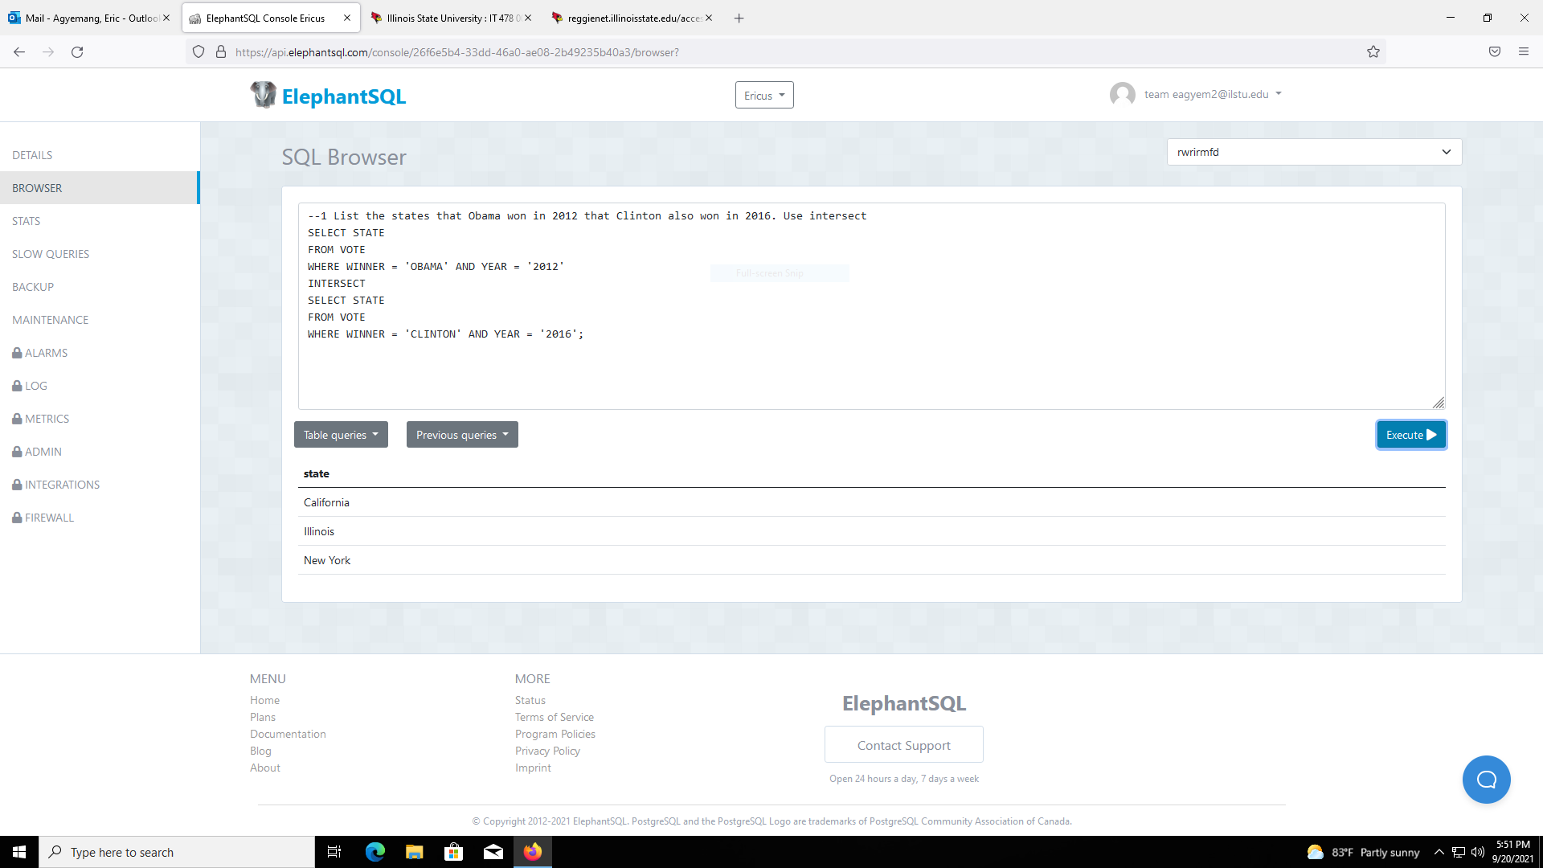

--2 List the states that Obama won in 2012 that Clinton also won in 2016. Use intersect ALL

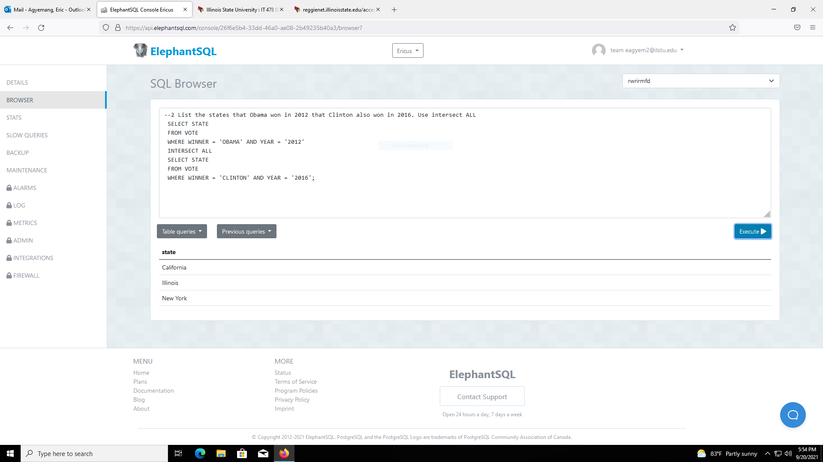

--3 List the states Obama won in 2008 that Clinton also won in 2016. Use Union All

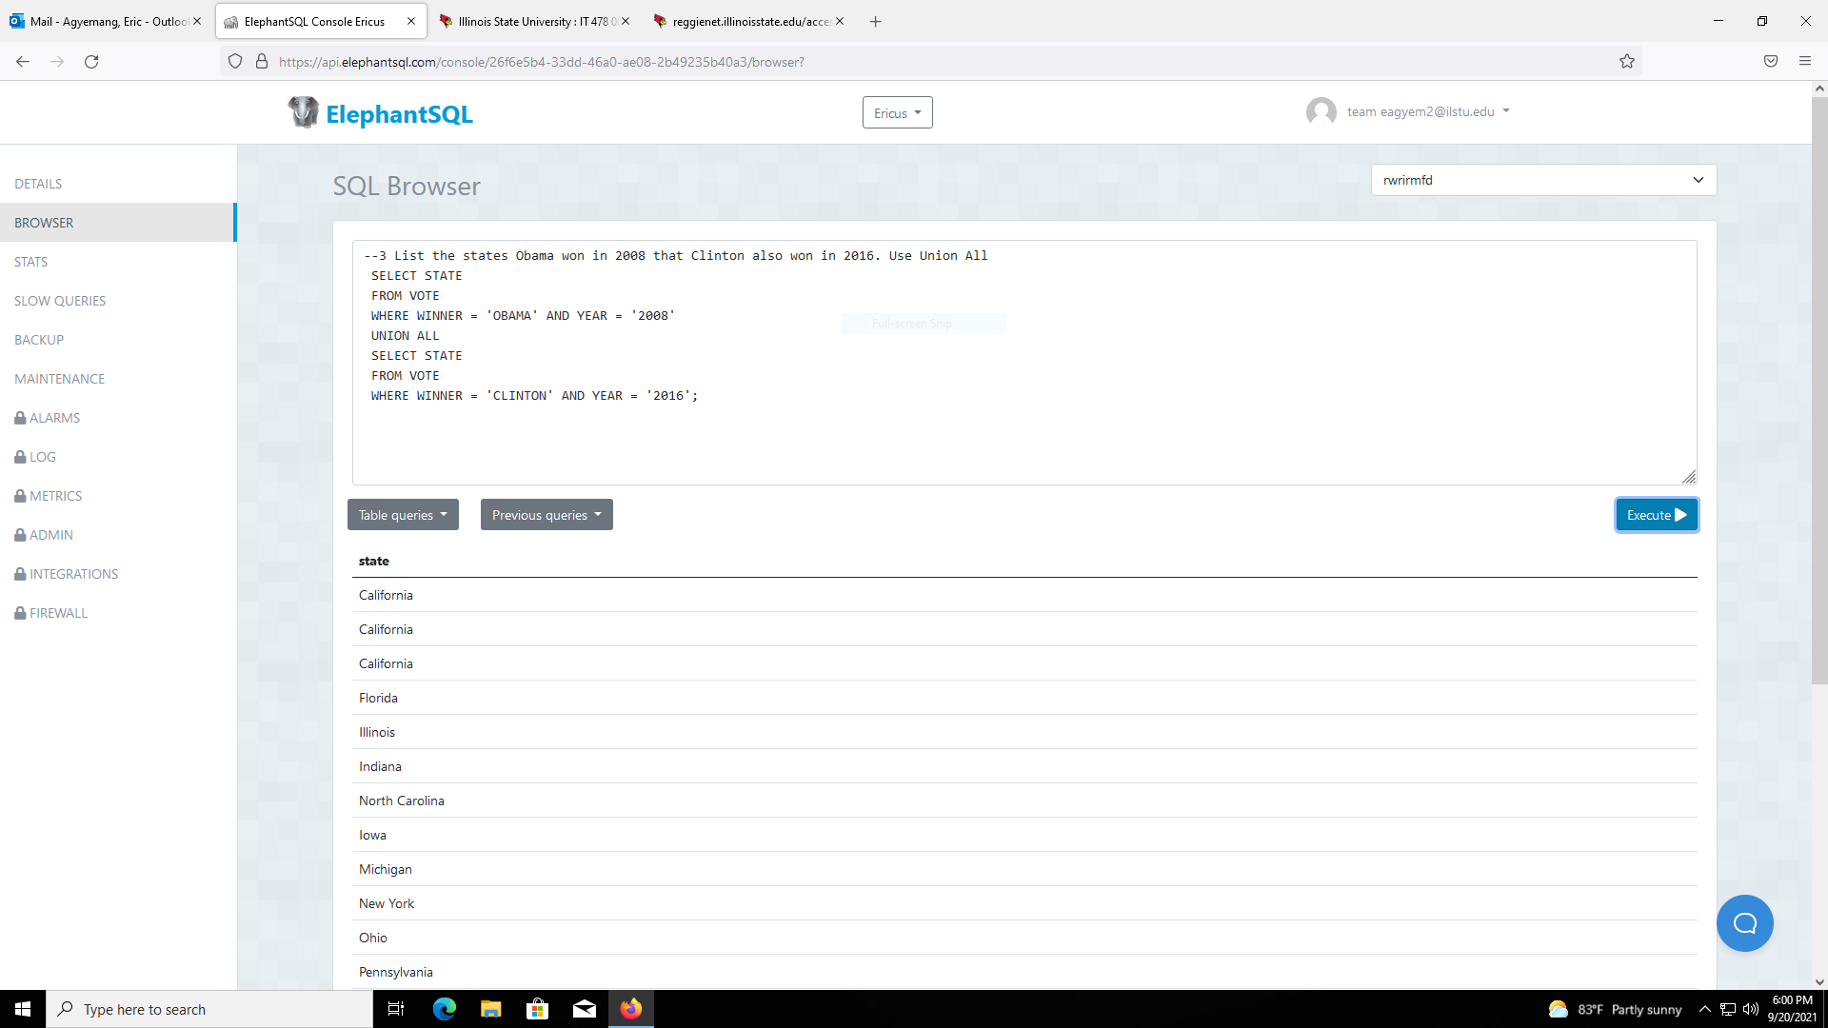

--4 List the candidate name and number of states won by Clinton and Trump in 2016 Use Union.

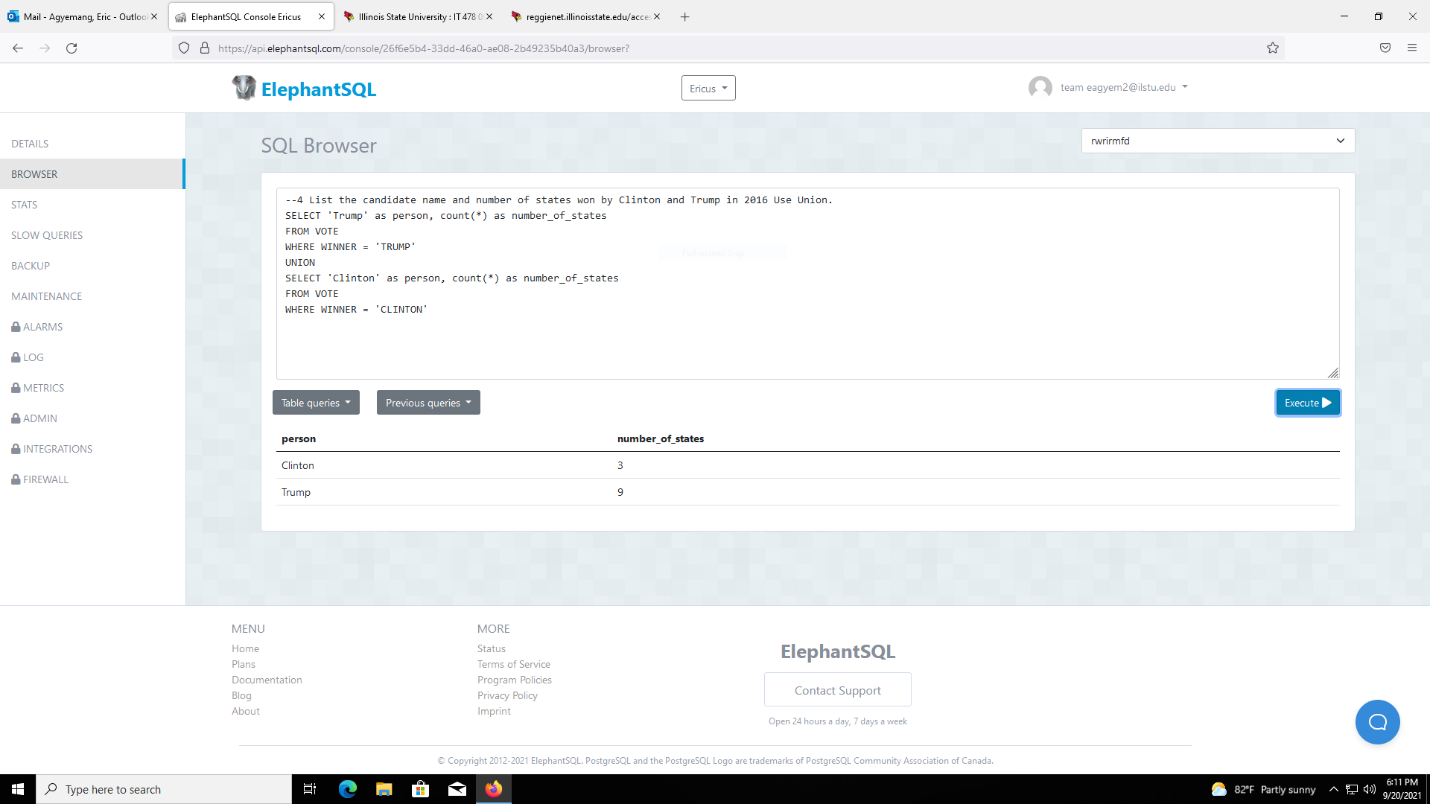

--5 List the States that Obama won in 2008 that he did not win in 2012. Use except

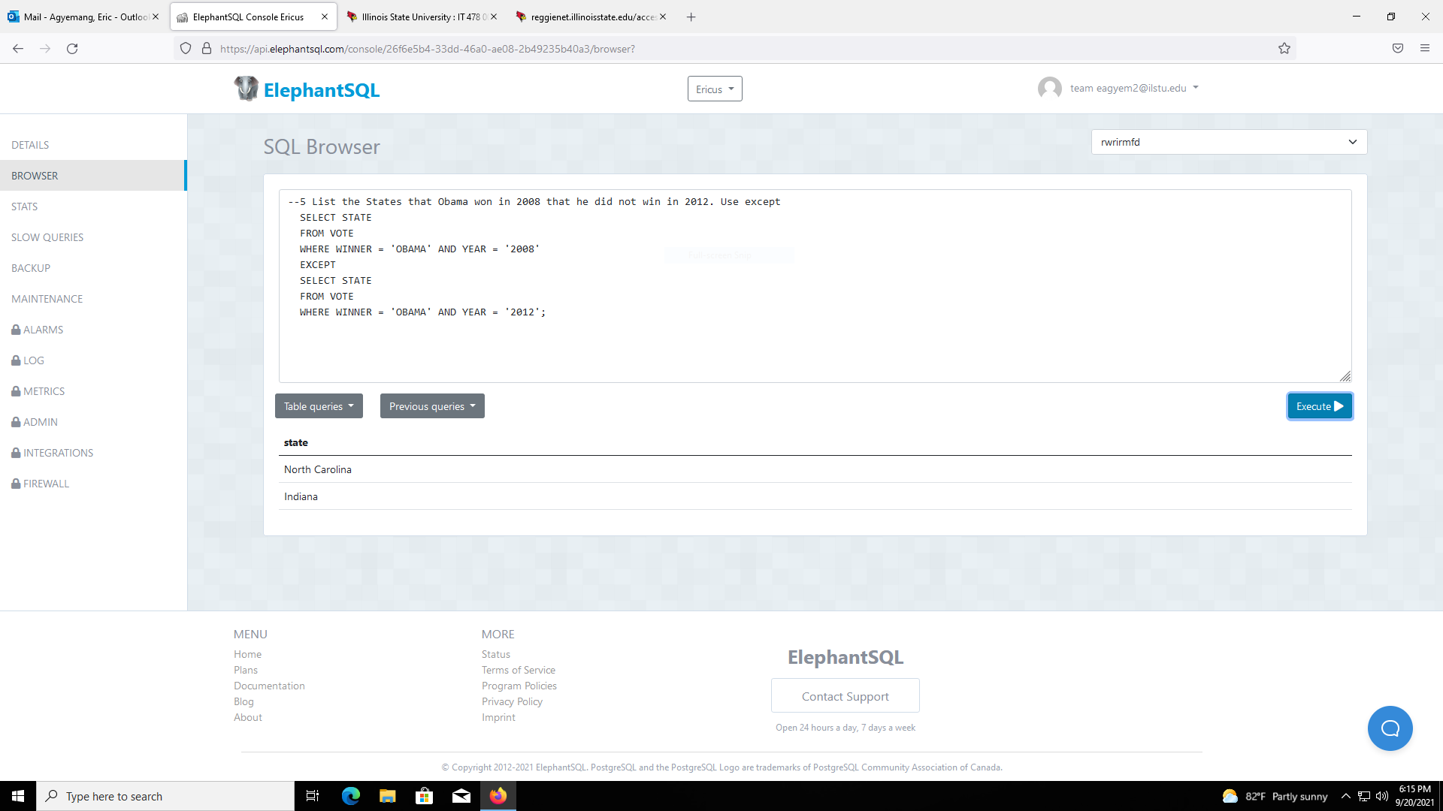

--6 List the States that Obama won in 2008 that he did not win in 2012. Use except ALL

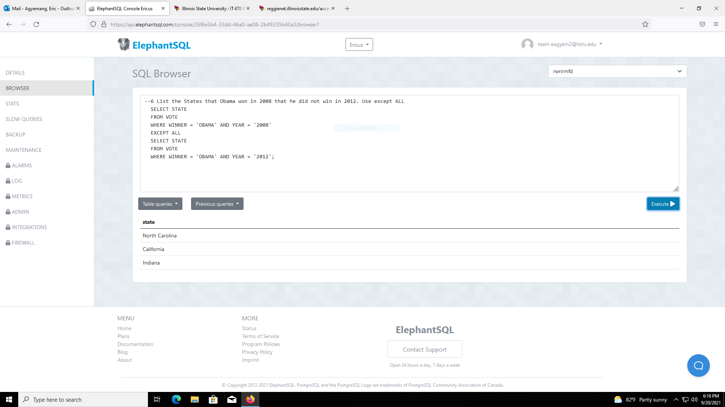

--7 List the States that Obama won in 2008 and 2012, that Clinton did not win in 2016.

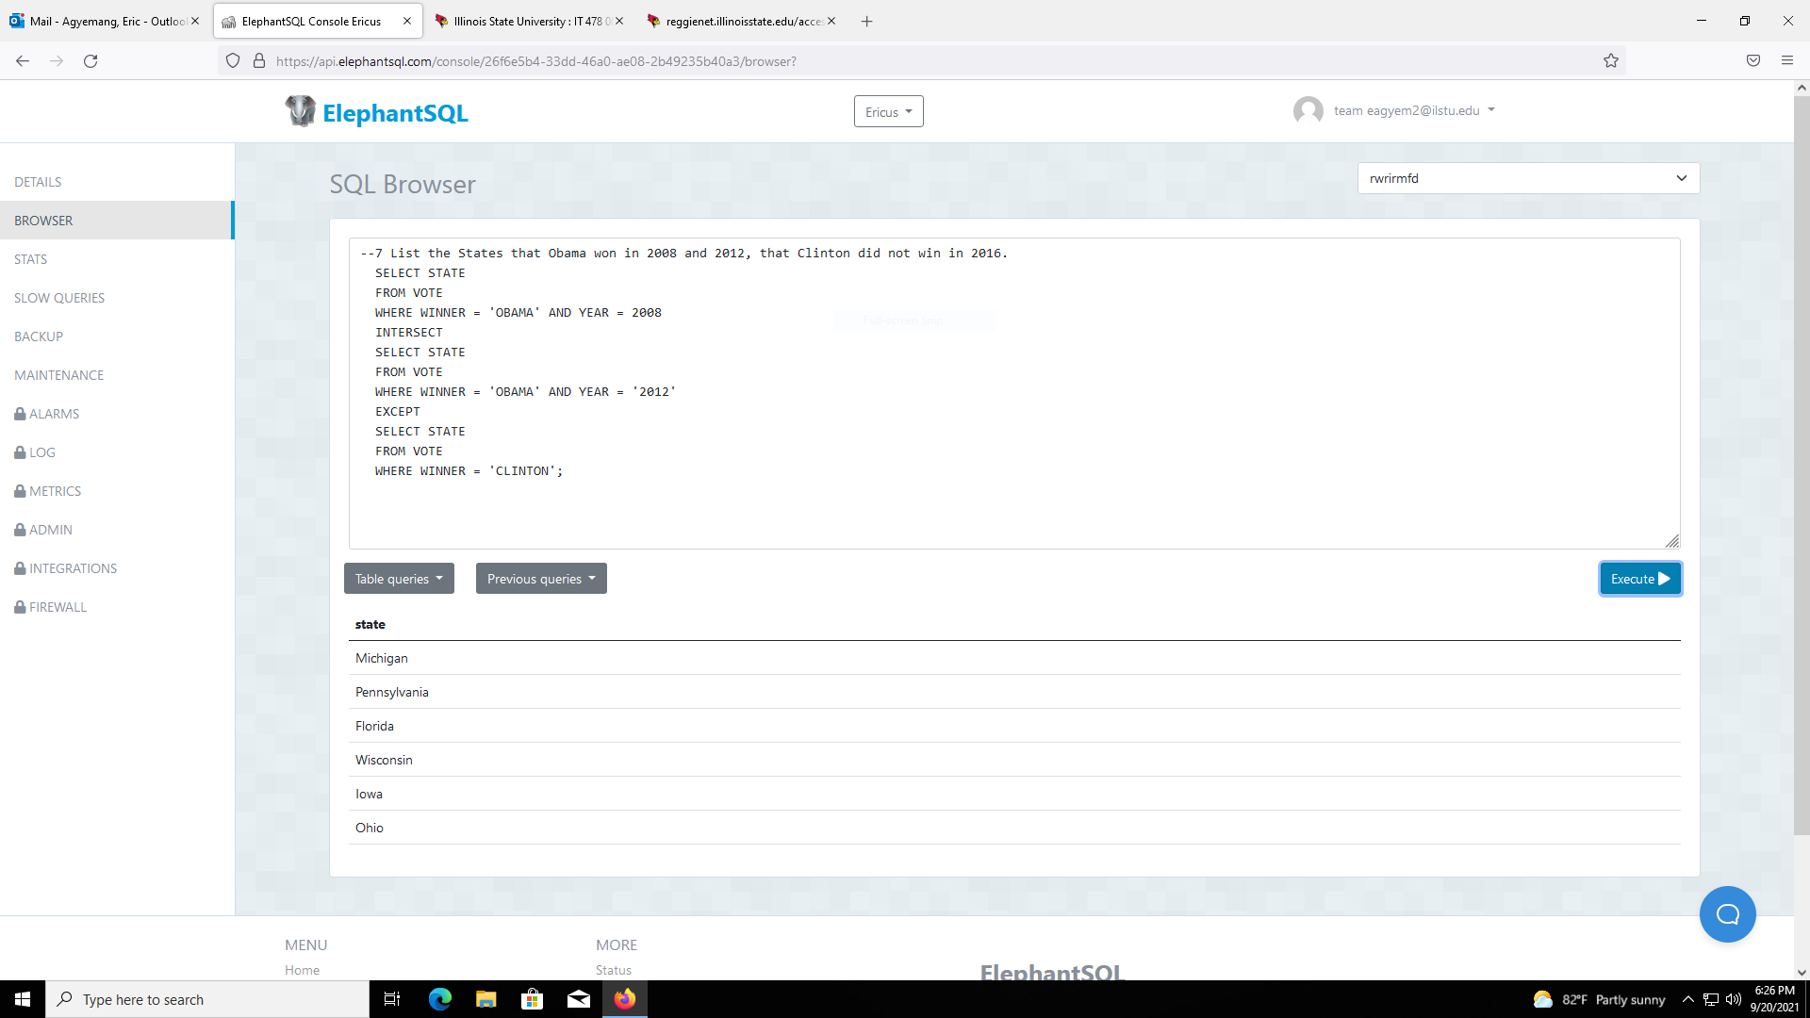

--8 List any States won by a different candidate in 2008, 2012, and 2016. That is a state that was won by 3 different candidates.

